**DAILY ONLINE ACTIVITIES SUMMARY**

|  |  |  |  |  |  |  |  |
| --- | --- | --- | --- | --- | --- | --- | --- |
| **Date:** | **15/06/2020** | | | | **Name:** | **Namratha C** | |
| **Sem & Sec** | **8th sem, A sec** | | | | **USN:** | **4AL16CS056** | |
| **Online Test Summary** | | | | | | | |
| **Subject** | | **SMS** | | | | | |
| **Max. Marks** | | **60** | | **Score** | | **No mail Received** | |
| **Certification Course Summary** | | | | | | | |
| **Course** | **Introduction to Information Security** | | | | | | |
| **Certificate Provider** | | | **Great Learning** | **Duration** | | | **5hrs** |
| **Coding Challenges** | | | | | | | |
| **Problem Statement: 1) Program to calculate power of a number using for loop** | | | | | | | |
| **Status: Completed** | | | | | | | |
| **Uploaded the report in Github** | | | | **Yes** | | | |
| **If yes Repository name** | | | | **CODES (Namrathasonu)** | | | |
| **Uploaded the report in slack** | | | | **Yes** | | | |

Online Test Details: **No Mail Received**

Certification Course Details:

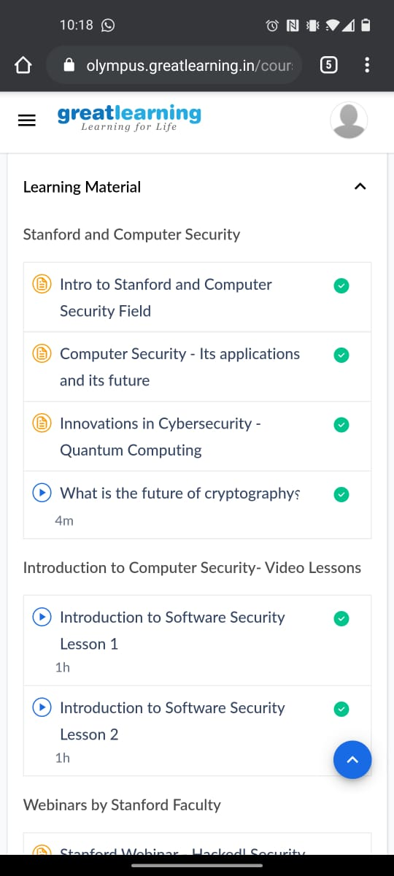

Coding Challenges Details:

1)

public class JavaExample {

public static void main(String[] args) {

int number = 2, p = 5;

long result = 1;

int i = p;

for (;i != 0; --i)

{

result *= number;

}

System.out.println(number+"^"+p+" = "+result);

}

}